**ENTRENAMIENTOS – JOBER MENA ZAMBRANO (1993613)**

|  |  |  |  |  |  |
| --- | --- | --- | --- | --- | --- |
| **N°** | **CURSO (ID)** | **NOMBRE DEL CURSO** | **HORAS** | **FECHA** | **% AVANCE** |
| **1** |  | **Kubernetes para administradores IT Esencial** | **0:59** | **28/11/2023** | **100%** |
| **2** |  | **Docker esencial** | **2:16** | **28/11/2023** | **100%** |
| **3** |  |  |  |  |  |
| **4** |  |  |  |  |  |
| **5** |  |  |  |  |  |
| **6** |  |  |  |  |  |

**EVIDENCIAS**

1. **0 – Kubernetes para administradores IT Esencial – 28/11/2023**

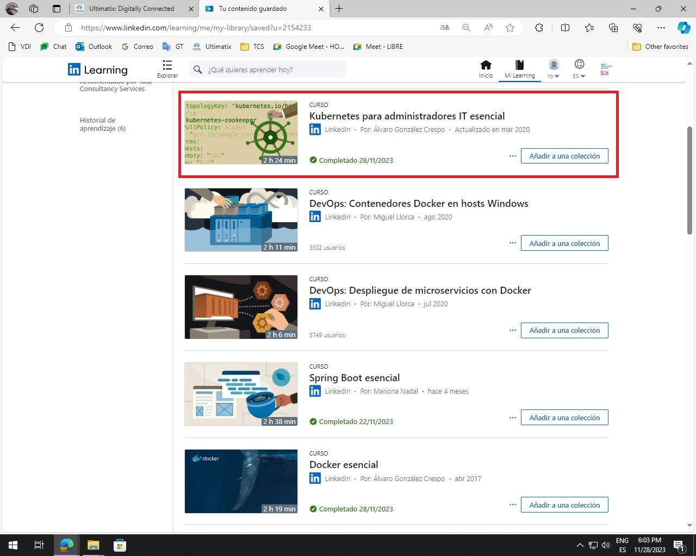

1. **0 – Docker esencial – 28/11/2023**

